 |  |  |  |  | Brief CV of the faculty member
The name: |  |  | Mohammed Nafee AL luhaybi |  |  | Academic rank: |  | Teacher |  | 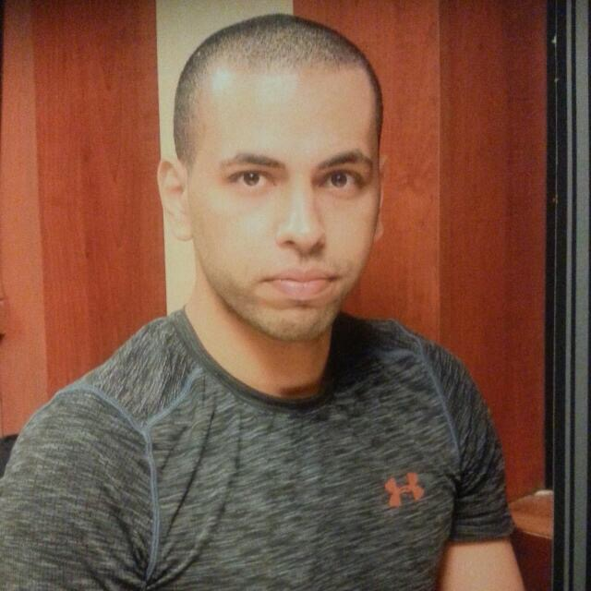
General specialty: |  |  | Special Education |  |  | Specialization: |  | Learning Disabilities
Phone number (optional): |  |  | +966 503086740 |  |  | E-mail: |  | mnafee@bu.edu.sa
Qualifications
□ PhD |  |  |  |  |  |  | □ M.A. |  |  |  | □ Bachelor of
PhD Thesis Title:
Master Thesis Title: |  | How to Improve Learning for Students with Disabilities in Saudi Arabia Using Assistive Technology that Come with Devices Like Tablets
Jobs
م | Title |  |  |  |  |  |  |  | School |  |  |  | Year
1 | Teacher in Ammar Bin Yasser Primary School |  |  |  |  |  |  |  | Ammar Bin Yasser – Saudi Arabia |  |  |  | 2013
2 | Teacher for English Language in Portsmouth High School – Training Course |  |  |  |  |  |  |  | Portsmouth High School - Ohio |  |  |  | 2019
3 | Arabic Teacher for one Semester in AL furqan Primary School |  |  |  |  |  |  |  | AL Furqan Primary School |  |  |  | 2018
4 | Lecturer in AL Baha University |  |  |  |  |  |  |  | AL Baha – Saudi Arabia |  |  |  | 2013 - Now
5
6
7
8
Scientific posts
Post type |  |  |  | the number |  | Post type |  |  |  |  |  | the number
Conferences: |  |  |  | 1 |  | Supervising scientific theses:
Seminars: |  |  |  | 1 |  | Discussing scientific messages:
Providing training courses: |  |  |  | 1 |  | Academic Committees and Work Teams:
Attending training courses: |  |  |  | 1 |  | Membership of scientific and professional societies:
Scientific Awards: |  |  |  |  |  | Membership of Community Committees:
Administrative experiences
م | Job name |  |  |  |  | The entity
1 | Assistant for Dr.Kheder in The Department of Special Education in 2013 – 2014. |  |  |  |  | School of Education – AL Baha University

